Week1 Assignment-Ximing Li

1. Python version:

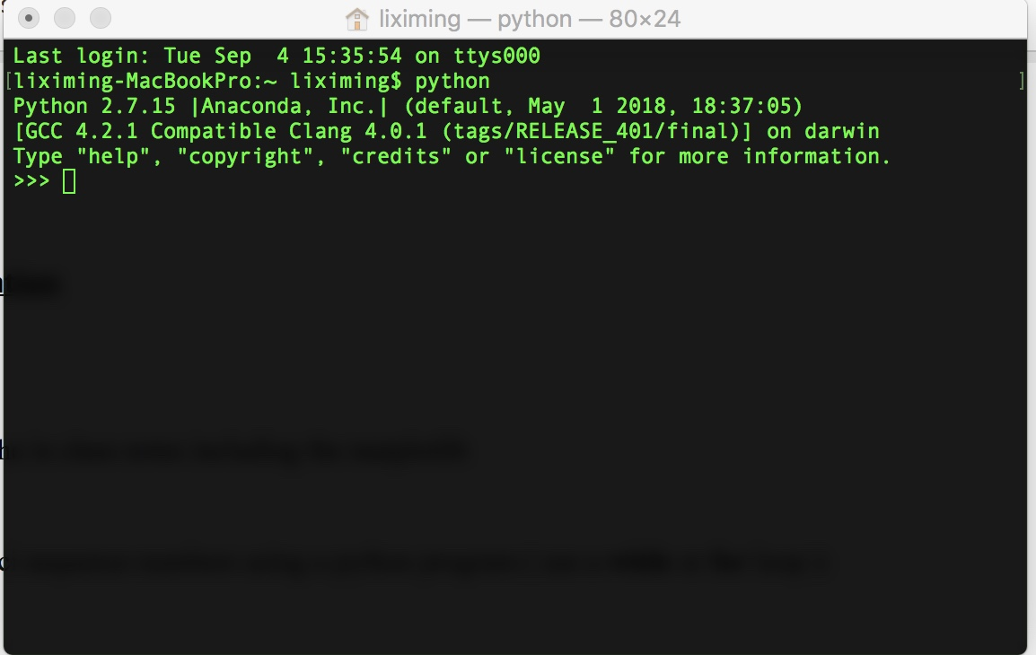

1. jupyter tests pages done in the in class notes including the matplotlib:

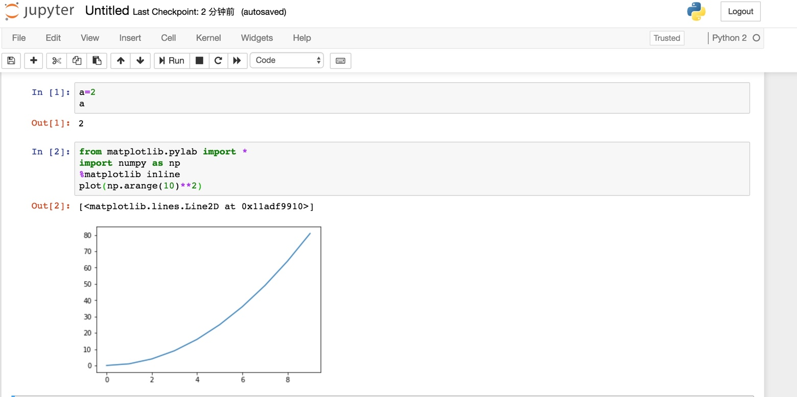

1. Spyder test:

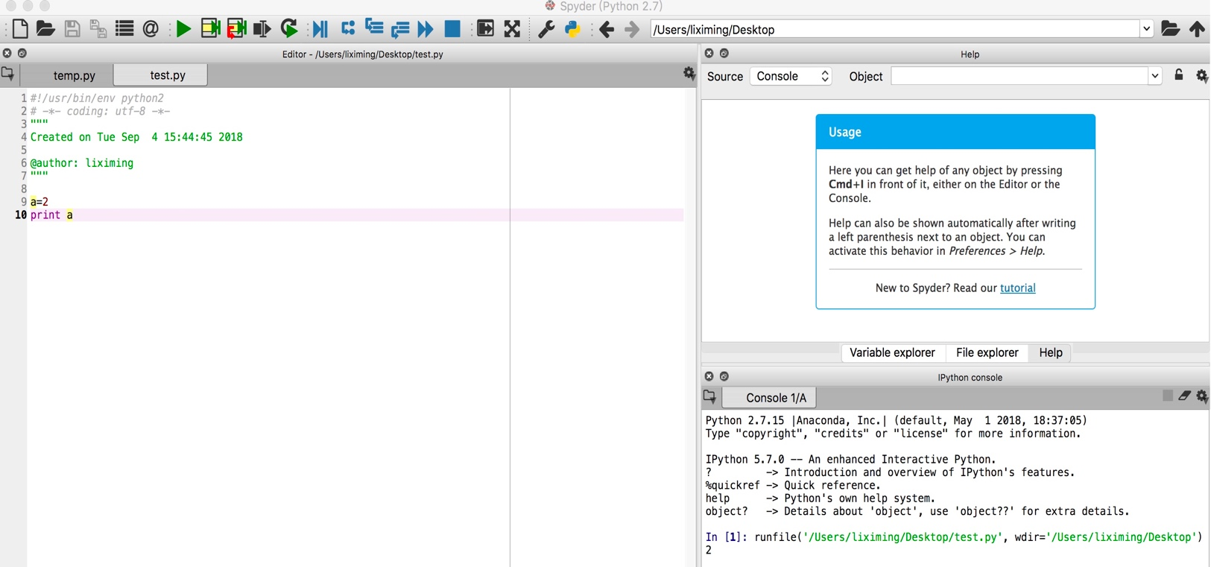

1. Generate the first 10 Fibonacci sequence numbers using a python program (use a while or for loop ):
2. Using Spyder:

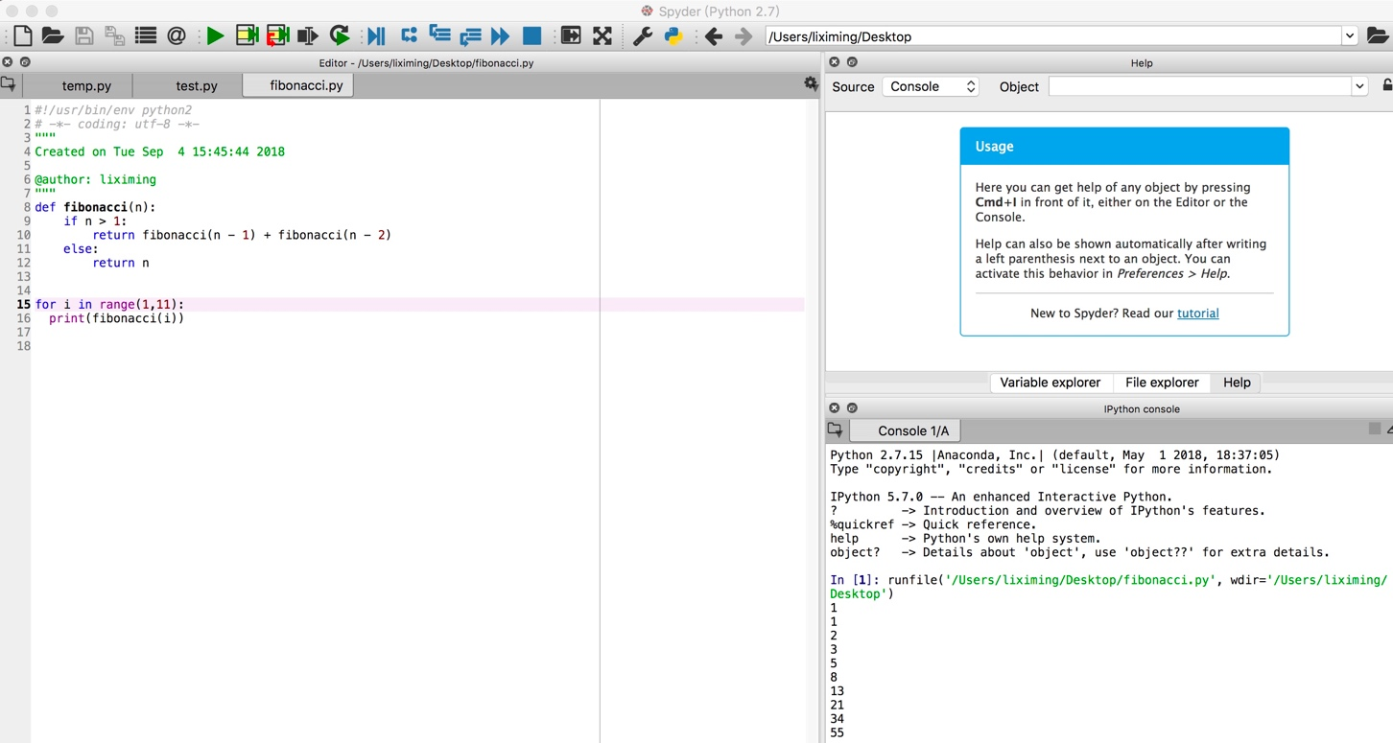

1. Using Jupyter notebook:

